A Birthday Recollection; Mother
(Bill Pigott, June 2018)
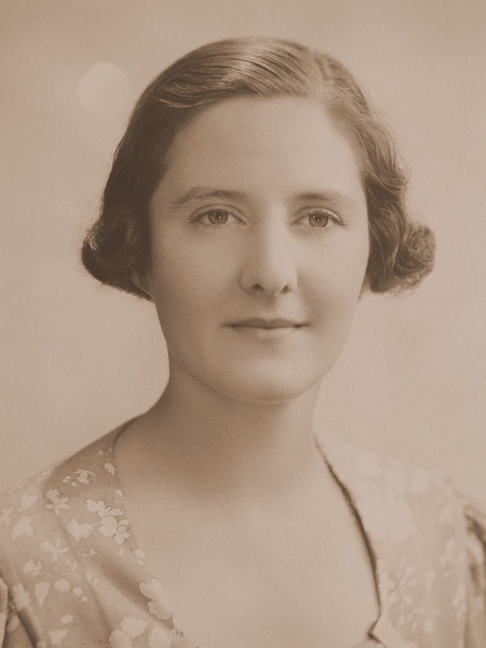
26th June was my mother's birthday (1914) and on this day this year I found myself recalling some of her stories of Yardea, a large sheep property in central South Australia, as I searched for information about camels and their Afghan drivers for Canadian friends who had just been in the Outback.
Mum was born in Petersburg, South Australia (soon to change its name to Peterborough) in 1914 and lived for a time in Port Augusta, where her father, Dr Peter Gorrie, as a GP-surgeon, was the only Medical doctor there, serving not only the town, but a huge area of rural South Australia. I imagine it was then that their family developed their long-time friendships with the owner and with the manager of Yardea and their families. She would tell her seven children tales of holidays spent there as a teenager, by which time the Gorries had moved to Stirling in the Adelaide Hills.
On one such holiday, she became ill. We are talking about the end of 1920s. Mr Brodie, the manager at Yardea, contacted her father in Mt Lofty. He arranged that the Yardea people should immediately set out by car for Port Augusta (some 380 km away on today’s roads, probably further in 1929 or 1930) and he would meet them there, driving from Stirling in the Adelaide Hills (some 350 km on today’s roads). Mum’s story of the car trip describes an epic journey. Every bump on the road hurt. (and the first part of the journey would have been more of a track that a road as we know it) They had punctures, so many that they just filled the tyres with sand, which made the bumps more painful.
After a 12-hour journey, they reached Port Augusta and met up with her father at the Port Augusta Hospital. He confirmed the diagnosis and decided that they should operate immediately. The only GP in Port Augusta deferred to the surgical skills of Dr Gorrie, her father, saying he would not operate on the daughter of a highly respected surgeon in his presence. So, the local doctor gave the anaesthetic and the father did the appendicectomy. My mother remembers her father saying to the other doctor to make sure her face was kept covered so he would not see it while he operated.
All ended well, but it must have been a harrowing adventure.
Three pictures:
1: Betty Gorrie, in 1934 or 1935 -above
2: The actual vehicle, a 1926 Bean Tourer, Dr Gorrie would have driven to meet the party from Yardea in Port Augusta.
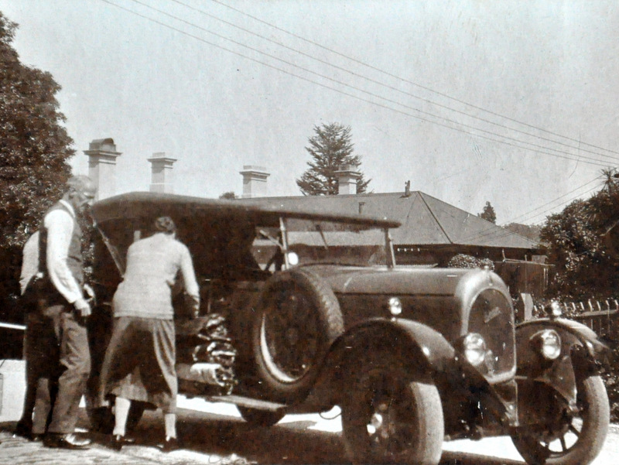
3: a picture from the web showing the "road' from Yardea in 1931 (State Library of SA).
